הסתברות

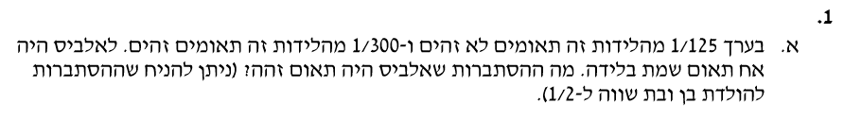

Answer:

P(Identical male twins) = $\frac{1}{300} ∙ \frac{1}{2} = \frac{1}{600}$.

P(Unidentical male twins) = $\frac{1}{125} ∙ \frac{1}{4} = \frac{1}{500}$. $\frac{P(Identical male twins) }{P\left(Identical male twins\right)+P(Unidentical male twins)}$ = $\frac{\frac{1}{600}}{\frac{1}{600}+\frac{1}{500}}$ = 0.4545

P(Male twins) = $\frac{1}{600} + \frac{1}{500}=$ $0.00366$.

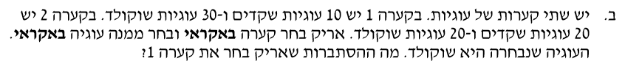

Answer:

P(bowl number 1) = $\frac{1}{2}$

P( chocolate from bowl number 1) = $\frac{3}{4} ⋅ \frac{1}{2} = \frac{3}{8}$ $\frac{P(chocolate from bowl number 1) }{P\left(chocolate from bowl number 1\right)+P(chocolate from bowl number 2)}$ = $\frac{\frac{3}{8}}{\frac{3}{8} +\frac{1}{4} }$ = 0.6

P( chocolate from bowl number 2) = $\frac{1}{2} ⋅ \frac{1}{2} = \frac{1}{4}$

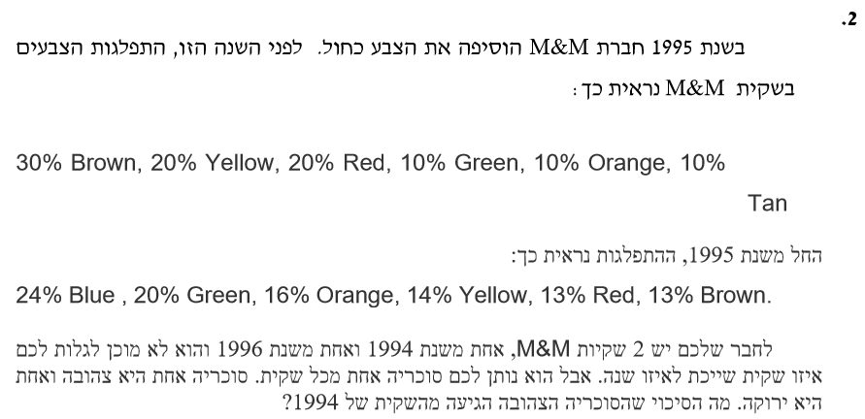

Answer:

$$\frac{P\left(yellow candy 1994\right)}{P\left(yellow candy\right)}=\frac{\frac{1}{5}}{\frac{1}{5}+\frac{14}{100}}=0.5882$$

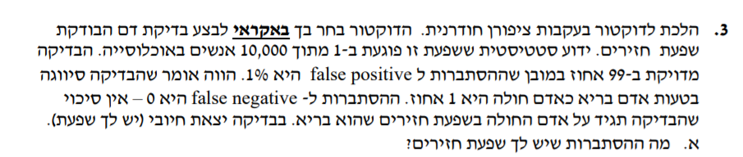

Answer:

$$P\left(sick\right)=\frac{1}{10,000}$$

$$P\left(positive / sick\right)=1$$

$$P\left(positive\right)=P\left(positive / sick\right)⋅P\left(sick\right)+P\left(positive / healthy\right)⋅P\left(healthy\right)=1⋅\frac{1}{10,000}+0.01⋅\frac{9999}{10,000}=0.010099$$

$$P\left(sick / positive\right)=\frac{P(positive / sick)⋅P\left(sick\right)}{P\left(positive\right)}=\frac{1⋅\frac{1}{10,000}}{0.010099}=\frac{100}{10099}=0.0099$$

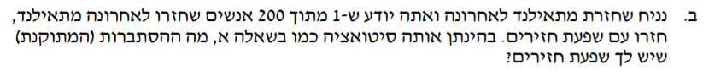

$$P\left(positive\right)=P\left(positive / sick\right)⋅P\left(sick\right)+P\left(positive / healthy\right)⋅P\left(healthy\right)=1⋅\frac{1}{200}+0.01⋅\frac{199}{200}=0.01495$$

$$P\left(sick / positive\right)=\frac{P(positive / sick)⋅P\left(sick\right)}{P\left(positive\right)}=\frac{1⋅\frac{1}{200}}{0.01495}=0.33444$$

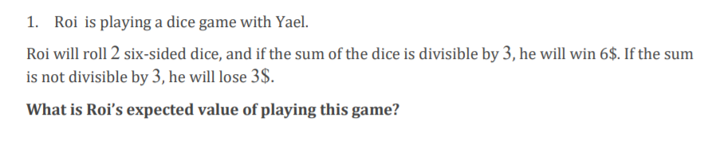

Answer:

|  |  |  |  |  |
| --- | --- | --- | --- | --- |
| The possible amounts: | **3** | **6** | **9** | **12** |
|  | 1,2  *2 | 2,4  5,1  *2  3,3 | 6,3  5,4  *2 | 6,6 |
| The number of options: | 2 | 5 | 4 | 1 |
|  |  |  |  |  |

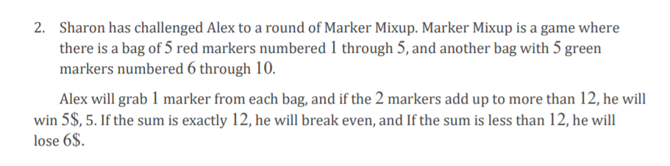



Answer:

all options: 5 $⋅$ 5 = 25

options for more than 12: [3 +10] , [4+9] , [4+10] , [5+8] , [ 5+9] , [5+10] = 6 options

options for 12: [2+10] , [ 3+9] , [4+8] , [5+7] = 4 options

options for less than 12: 25 - 10 = 15 options

$P(12) = \frac{4}{25}= 0.16$ $P(less than 12) = \frac{15}{25}= 0.6$ $P(more than 12) = \frac{6}{25}=0.24$

$0.24⋅5+ 0.16⋅0+$ $0.6⋅\left(-6\right)=-2.4\$$

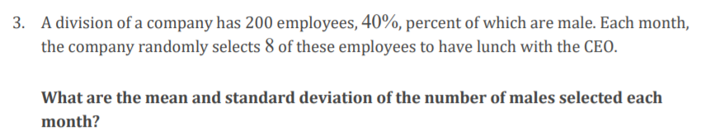

Answer:

The mean: $selected people⋅percentage of men in total workers=8⋅0.4=3.2$

Standart deviation: $\sqrt{\frac{1}{n}⋅\sum_{i=1}^{n}{(x-\overline{x})^{2}}}$

$$n=9 (9 options, 0-8 selected malls)$$

$$\sqrt{\frac{1}{9}⋅{\left(0-3.2\right)}^{2}+{\left(1-3.2\right)}^{2}+{\left(2-3.2\right)}^{2}+{\left(3-3.2\right)}^{2}+{\left(4-3.2\right)}^{2}+{\left(5-3.2\right)}^{2}+{\left(6-3.2\right)}^{2}+{\left(7-3.2\right)}^{2}+{\left(8-3.2\right)}^{2}}=2.703$$

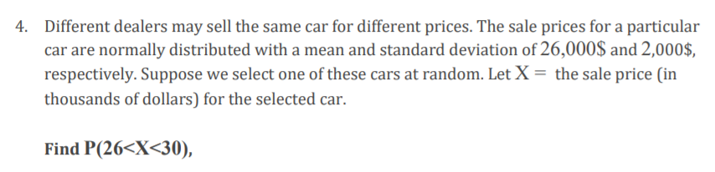

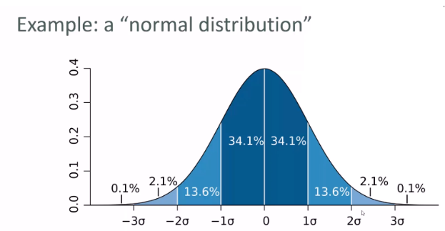

28,000$

30,000$

Mean: 26,000$

each section: 2000$

Answer:

$$P\left(26<x<30\right)=34.1\%+13.6\%=47.7\%$$

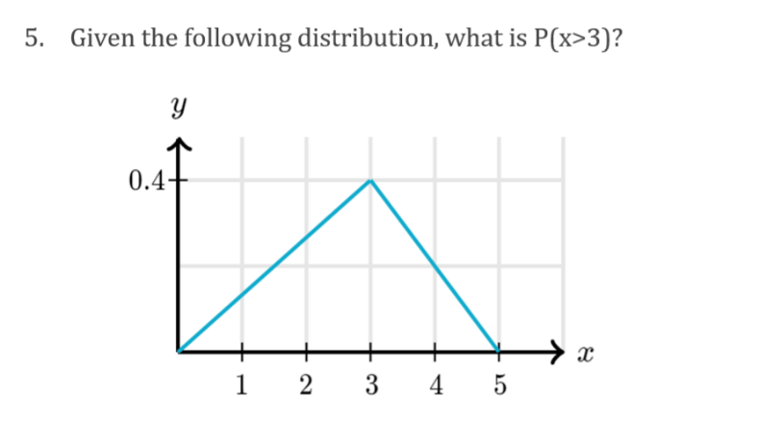

Answer:

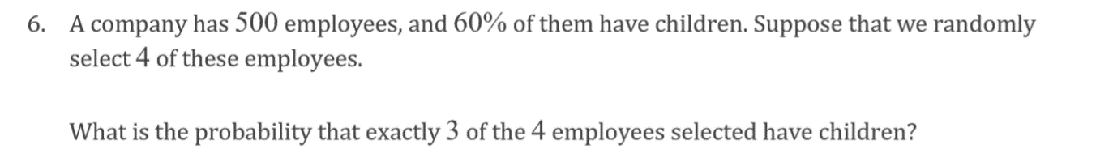100% of the total probability = triangle's area. For $P\left(x>3\right)$ we assisted with area calculation.

$$P\left(x>3\right)= \frac{0.4⋅2}{2}=0.4$$

Answer:

$P(three have children, one have no children)=\frac{300}{500}$ $⋅\frac{299}{499}⋅ \frac{298}{498}⋅\frac{200}{497}$ = 0.0865

There are 4 such identical options for each of the 4 people who can be childless and the rest yes, so:



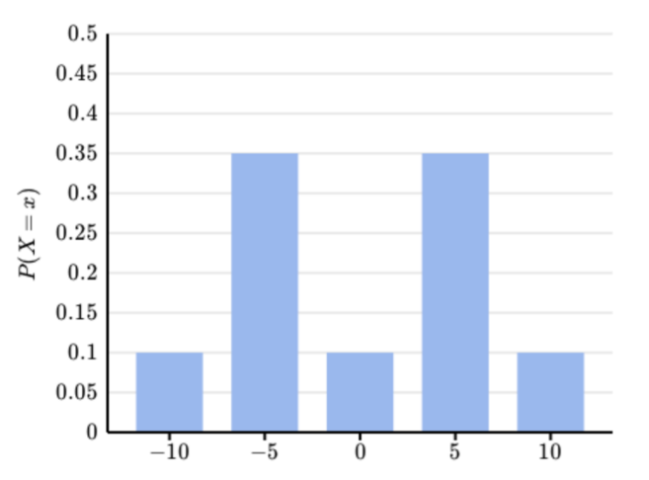

Answer:

$$\sum_{i=0}^{n}{P(x_{i})×x_{i}}$$

$$\left(-10⋅0.1\right)+\left(-5⋅0.35\right)+\left(0⋅0.1\right)+\left(5⋅0.35\right)+\left(10⋅0.1\right)=0$$